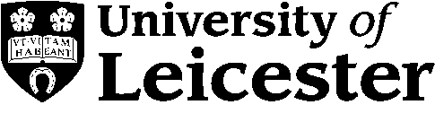**May Examinations 2014**

|  |
| --- |
| **DO NOT OPEN THE QUESTION PAPER UNTIL INSTRUCTED TO DO SO BY THE CHIEF INVIGILATOR** |

|  |  |
| --- | --- |
| **Department** | **School of Management** |
| **Module Code** | **MN2121** |
| **Module Title** | **Consumer Research** |
| **Exam Duration**  (in words) | **One and a half hours** |

|  |
| --- |
| **CHECK YOU HAVE THE CORRECT QUESTION PAPER** |

|  |  |
| --- | --- |
| **Number of Pages** | **2** |
| **Number of Questions** | **5** |
| **Instructions to Candidates** | Please answer **TWO** out of the following five questions.  All questions are worth equal marks |

|  |  |
| --- | --- |
| **For this exam you are permitted to use the following** | |
| **Calculators** |  |
| **Books/Statutes** |  |
| **Additional Stationery** |  |

1. What functions does branding serve? In answering, please consider whether it is now an essential function of business.
2. Explain and critically assess the concept of relationship marketing.
3. What principles and concepts are especially important in an international marketing context? Using an example (or examples) may help you think through this question.
4. What are the advantages and disadvantages of the marketing communications tools we discussed (public relations, advertising, personal sales, direct marketing, and promotions)?
5. What are the ethical and political stakes involved in international marketing?

**[I frequently also add the following to exam questions: Please provide examples throughout to illustrate your understanding.]**

**END OF PAPER**